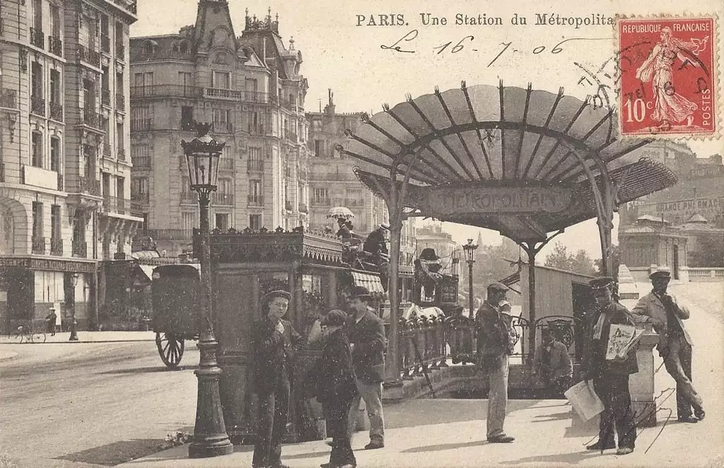

The Spring School 2019 “Management, preservation and representation of the industrial and mobility heritage: the experience of Paris”

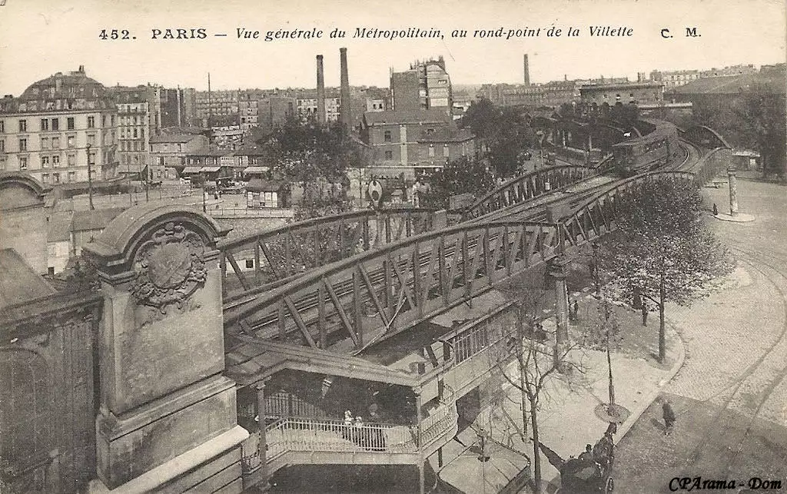
(11 - 15.06.2016, Paris, France)
Day 0. 10.06, Monday.
Arrival to Paris, accommodation.
15-00 – Meeting on the Reception of Enjoy Hostel.
16:00 – (Russian Center for Science and Culture in Paris, 61 Rue Boissière) - Introductory seminar, discussion. World Expositions and the technological heritage of Paris. Discussion of reading.
Reading for the day:
- Maria Gravari-Barbas (2019) What makes Paris being Paris? Stereotypes, simulacra and tourism imaginaries, Journal of Tourism and Cultural Change, 17:1, 27-41.
- Patrick Young From the Eiffel Tower to the Javanese Dancer: Envisioning Cultural Globalization at the 1889 Paris Exhibition, The History Teacher, Vol. 41, No. 3 (May, 2008), pp. 339-362
18:00 – 18:30 – Observation of heritage between Trocadero and Eiffel tower.
Task for students – prepare comments for the walk.
19:00 – Welcome picnic on the Mars fields.

Day 1. 11.06, Tuesday.
9-00 – Meeting on the Reception of Enjoy Hostel.
10:00 (Universite Paris 7 Diderot) - Welcome by Pr. Sophie Coeuré, head of Master in History, Dr. Laurence Gillot, head of curse in heritage, Konstantin Volkov, Director of the Russian Center for Science and Culture in Paris.
10:30 - Keynote lecture by Pr. Liliane Hilaire-Perez “History of technology in the French context”.
Recommended reading:
- Arnaud Passalacqua, « Reluctant capitals: transport mobility and tramways in London and Paris 1830-1950 », Town Planning Review, vol. 85, n° 2, 2014, p. 203-216
- Carlos Lopez-Galviz, « Metropolitan railways: urban form and the public benefit in London and Paris c.1850-1880 », The London Journal, 2013, 38, 3, p. 184-202

12:00 Lunch break (Dr. Laurence Gillot joins us).
13:30 - Lecture by Dr. Irina Gouzevitch Ecole Polytechnique and the circulation of technical knowledge between St. Petersburg and Paris.
Reading of the day:
- Hélène Vérin & Irina Gouzévitch (2011): The rise of the engineering profession in eighteenth century Europe: an introductory overview, Engineering Studies, 3:3, 153-169.
- Irina Gouzévitch, Technical higher education in nineteenth‐century Russia and France: Some thoughts on a historical choice, January 1995 History and Technology an International Journal(2):109-117
15:00 – Break.
15:30 – 16:00 Discussion.
16:00 – 19:00 – Observation of the industrial and technological heritage of the Gare de Lyon area – railway stations, Viaduc des Arts, Bassin de l'Arsenal.
Task for the students – comments for the walk.
20-00 (20-30) Professors - Dinner with the Paris Diderot colleagues.
Observation of industrial, technological and mobility heritage in Paris, Day 2.
9:30 - visit to the Musee d’Orsay. Group work – observation of Modernity through Arts: Group 1 – How the Modern technologies were used to create the paintings? Group 2 – How the Modern technologies are depicted on the paintings?.
12:30 – Lunch break.
14-15:15 - visit of Eastern Station (Gare de l'Est) : history, architecture, heritage (Dr. Arnaud Passalacqua).
MEETING POINT : at the café called « Les Tramways de l'Est », 76, boulevard de Strasbourg.

15:15 - 16:30 - session with the association « Rails & Histoire » (9, rue du Château-Landon). Presentation of the association and its activities: oral records (railworkers during WW2), railway heritage (the switch station in Lyon).
17:00 – 18:30 – Observation of the technological heritage of the Middle Ages and Early Modern time – Pont Neuf, Gothic Architecture).
Task for the students – comments for the walk.
19:00 (Russian Center for Science and Culture in Paris, 61 Rue Boissière) – Discussion of readings, brief discussions of the day results. Presentation of observations in Orsay.

Readings for the day:

- David L Pike (2011) Paris#Souterrain: Before and After the Revolution, DixNeuf, 15:2, 177-197.
- Sara Galletti. “Female Agency and Early Modern Urbanism: The Paris of Maria De’ Medici.” Journal of the Society of Architectural Historians, vol. 71, no. 2, 2012, pp. 186–203

Day 3. 13.06, Thursday
Observation of industrial, technological and mobility heritage in Paris, Day 1.
9-15 — Departure from the hotel.
10:00 - Visit to the Musée des arts et métiers. ((Group work – observation of technologies by environment – 1. Control of water, 2. Control of land, 3. Control of air). ).
Recommended Reading:
Marco Beretta, «Between the Workshop and the Laboratory: Lavoisier’s Network of Instrument Makers ». Osiris, 2014, 29(1), 197-214.

12:30 – Lunch break.
14:30 - Visit to the Museum of Mineralogy and the archives of the Ecole des Mines (Dr. Laurence Gillot).
Recommended Reading:
- Laboulais Isabelle, Vogel Jakob, « The Construction of the profession of Mining Engineer tested ‘in the field’ during the Revolution and Empire”, Annales historiques de la Révolution française, vol. no 385, no. 3, 2016, pp. 47-66.
- Jeff HORN et Margaret C. JACOB, « Jean-Antoine Chaptal and the Cultural Roots of French Industrialization », Technology and Culture, 39:4 (1998), 671–698
16:00 - A lecture from the experts of the Société d’Encouragement pur l’industrie nationale (1801, still existing), St Germain des Prés (Dr. Laurence Gillot).
17:30 – Observation of the Modern technological heritage – Pont Alexandre III, Grand Palais, Petit Palais, embankments (Dr. Laurence Gillot).
Task for the students – commentary for the walk.
19:00 (Russian Center for Science and Culture in Paris, 61 Rue Boissière) – Discussion of readings, brief discussions of the day results, presentations by groups.
Readings of the Day:
- Masha Belenky (2012) Transitory Tales: Writing the Omnibus in Nineteenth-Century Paris, Dix-Neuf, 16:3, 283-303.
- Tricia Cusack (2007) Bourgeois Leisure on the Seine: Impressionism, Forgetting and National Identity in the French Third Republic, National Identities, 9:2, 163-182

Day 4. 14.06, Friday
9h30 – Professors - Meeting with Paris Diderot staff for further collaboration.
Students - Time for the preparation to the concluding seminar.
11:00 - Observation of the industrial heritage of Universite Paris Diderot (industrial mills).
13:00 – Lunch break.
14:30 - Observation of the industrial heritage of the Ecole d’Architecture (Dr. André Del, Dr. Laurence Gillot).
16:00 – Observation of Galerie Lafayette, Opera Garnier, Grand Boulevard.
Task for students - Heritage of mass consumption, commentary for the walk.
19:00 - (Russian Center for Science and Culture in Paris, 61 Rue Boissière) – Discussion of readings, brief discussions of the day results.
Readings of the day:
- Bocquet (D.), Chatzis (K.) & Sander (A.), « From free good to commodity: universalizing the provision of water in Paris, 1830-1940 », Geoforum, vol. 39, n° 6, 2008, p. 1821-1832
- Igra, Caroline. “Constructing an Image. The Development of La Vie Moderne in Third Republic Paris.” Zeitschrift Für Kunstgeschichte, vol. 69, no. 1, 2006, pp. 109–114.

Day 5. 15.06, Saturday
10:00 (Paris Diderot)- Russian-French seminar “Ville, architecture, patrimoine”, presentations from students, discussion. .
13:00 - Lunch Break.
14:30 – Visit to the Atelier des Lumières project (38 Rue Saint-Maur), Invitation from Culturespaces Company.
17:00 — Concluding picnic, Botanical Garden.
Day 6. 16.06, Sunday.
Departure.
The list of participants:
Professors:
- Alexei Kraikovski.
- Margarita Dadykina.
Students:
- Daria Snigir.
- Aleksandra Babikova.
- Anna Petrova.
- Elena Krasilnikova.
- Mikhail Vsemirnov.
- Yadhav Deerpaul.
- Georgii Bozhchenko.
In total 9 persons.

