HSE St. Petersburg School of Economics and Management (HSE SEM)
Санкт-Петербургский филиал Федерального государственного автономного образовательного учреждения высшего профессионального образования «Национальный исследовательский университет
“Высшая школа экономики”»
Факультет Санкт-Петербургская школа экономики и менеджмента

Программа вступительного экзамена
для направления 38.04.08 «Финансы и кредит» подготовки магистров Образовательная программа «Финансы»
Язык проведения экзамена - английский
Авторы программы:
Назарова В.В, к.э.н., доцент, департамент финансов, vnazarova@hse.ru
Макарова В.А., к.э.н., доцент, департамент финансов, vmakarova@hse.ru
Утверждена

Санкт-Петербург
2022
HSE St. Petersburg School of Economics and Management (HSE SEM)
1. General information
1.1. The admission exam has the form of a written test with the duration of 90 minutes
1.2. This admission exam evaluates verbal, mathematical, logical and analytical skills and abilities that are necessary for applicants to complete successfully their master's studies in Master in Finance Programme.
1.3. The structure of the exam: the exam consists of the Quantitative session and Integrated Reasoning.
The section of the exam, Quantitative, is devoted to mathematics. This part includes at least 15 problems in arithmetic, geometry, algebra, combinatorics and statistics.
The Quantitative session estimates basic math and analysis skills, ability to solve quantitative problems. Each assignment has 5 choices, and the applicant should choose one correct answer.
Then comes the Integrated Reasoning part, where the student answers less than 10 questions in different formats in writing, such as analyzing graphs and tables, solving theoretical problems. This part of the exam is aimed at testing the development of entrepreneurial skills, strategic thinking, planning, and the ability to analyze information. The Integrated Reasoning section exam tests skills that business school faculty identify as important for success in the classroom, such as ability to analyze data presented in a case study.
Each assignment has 5 choices, and the applicant should choose one correct answer.
1.4. The Quantitative session contains 15 questions: 10 questions are worth 3 points for each correct answer, 5 questions are worth 5 points for each correct answer
The Integrated Reasoning section contains 10 questions: 5 questions are worth 4 points for each correct answer, 5 questions are worth 5 points for each correct answer.
Thus, the total number of points that an applicant can obtain, equals to 100.

2. Main topics
2.1. Quantitative section
- 2.1.1. Quantitative section contains at least 15 assignments of 6 types:
Data sufficiency (A statement is sufficient when it guarantees exactly one answer to that question).
- Number properties
  - Integers & Rules of Divisibility by Certain Integers
  - Factors and Multiples
  - Divisibility and Addition/Subtraction
  - Primes &Prime Factorization
  - The Prime Box
  - Greatest Common Factor and Least Common Multiple
  - Remainders
- Statistics
  - Mean
  - Median
  - Mode
  - Range
  - Standard Deviation
- Combinatorics
  - Enumeration
  - Combination
  - Permutation
- Probability
  - Independent events
  - Mutually exclusive events
  - Combination of independent and mutually exclusive events
- Integrated reasoning
Any assignments require to solve a problem and to choose one correct answer from five options.
Data sufficiency questions consist of assignment formulation and two statements marked (1) and (2). The applicant must decide if the given information is sufficient to answer the question. The applicant must choose between the following answers:
- if you can get the answer from (1) ALONE but not from (2) alone;
- if you can get the answer from (2) ALONE but not from (1) alone;
- if you can get the answer from BOTH(1) and (2) TOGETHER, but not from
(1) alone or (2) alone;
- if EITHER statement (1) ALONE OR statement (2) ALONE suffices;
- if you CANNOT get the answer from statements (1) and (2) TOGETHER,
but need even more data.
Or select a specific value from the 5 suggested.
2.1.2. Basic terms:

2.1.2.1. Natural numbers. Divisibility. Prime numbers and composite numbers. Greatest common divisor and lowest common multiple. Integer, rational and real numbers. Percent. Absolute value, power, root, arithmetical root, logarithm.

2.1.2.2. Numerical and algebraic expressions. Equalities and identities. Function, domain and codomain. Increase, decrease, periodicity, evenness, oddness of function. Max and min value of function. Function graph. Linear, quadratic, power, exponential and logarithmic function. equation, inequalities, combined equations. Solution of equation, inequality and combined equations. equivalence. Arithmetic and geometric series.

2.1.2.4. Logic. Necessary and sufficient condition.

2.1.3. Theoretical part
2.1.3.1. Arithmetic and algebra

Sets – basic terms. Set operation. A Venn diagram.
Number axis. Positive, negative numbers. Absolute value and its geometric sense.
Natural numbers (N). Prime and composite number. Divisor, multiple. Greatest common divisor and lowest common multiple.
Criterion for divisibility for 2, 3, 5, 9, 10. Division with a remainder Integer numbers (Z). rational quantities (Q), addition, subtraction, multiplication and division.
Proportions.
Decimal and ordinary fraction, its transformation one to the other. Round-up with prescribed accuracy.
Power with natural, integer and rational value. Arithmetical root. Operations with powers.
Percent calculation. Bank interest, compound interest.
Function. Function assignment (table, graph). Function increasing and decreasing.
Polynomial with one variable. Root of polynomial. Properties and graph of quadratic polynomial. Formula for quadratic polynomial roots. Vieta’s theorem.
Numerical expression. Expression with variables. Algebraic manipulation, formulas for short multiplication.
Equation. The root of an equation. Equivalent equations.
Two combined linear equations with two variables and it properties. Inequalities. Properties of numerical inequalities. Solving inequality with a variable. Equivalent inequalities.

Arithmetic and geometric series.
The method of coordinates on a plane (foundations).
2.1.3.2. Combinatorial calculus, probability theory and statistics.
Permutations, arrangements, combinations. Arithmetic mean, median, mode.
Standard deviation.
2.1.3.3. Geometry
Line, ray, segment, broken line; segment length. Angle, the measure of angle. Vertical and contiguous angles. Parallel lines, angles with parallel lines.
Triangle. Median, bisector, altitude. Criteria for equivalence of triangles. The interior angles of a triangle and it sum. Types of Triangles. Properties of isosceles and equilateral triangles.
Right-angled triangle. Pythagorean theorem, numerical right triangle. Quadrangle: parallelogram, rectangle, rhomb, square, trapezium. Circumference and circle. center of circle chord, diameter, radius. Tangent to circle.
Circuit.
Similarity. Criteria for similarity of triangles. Relations between linear elements and areas of similar triangles.
Formula for surface area and volume of prism. Formula for surface area and volume of pyramid. Formula for surface area and volume of cylinder. Formula for surface area and volume of cone. Formula for volume of sphere Necessary and sufficient condition.

2.2.Integrated Reasoning
Each multi-source reasoning question is based on a series of information contained in text, charts, or tables. For each practice question you should examine the relevant information and select the best answer of the choices given. This part includes: Multi-Source Reasoning, Graphics Interpretation, Integrated Reasoning Tips
The economic environment of business and finance
- The macroeconomic environment
- The market mechanism
- Financial market
- Demand
- Supply
- The equilibrium price
- Types of market structure
- The failure of perfect competition
- Risks for businesses and their investors
- Types of risk
- The objectives of risk management
- Types of performance measure
- Profitability , Activity, Productivity
- Measuring resource use: effectiveness, economy and efficiency
- Identifying key performance indicators

3. Recommended Literature

Main literature:
1. Graduate Management Admission Council (GMAC). The Official Guide for GMAT Review 2016. (2015). Hoboken, New Jersey: John Wiley & Sons, Inc.
2. GMAT Prep Plus 2020: 6 Practice Tests + Proven Strategies + Online + Mobile (Kaplan Test Prep) (2019). Kaplan Publishing, Inc.
3. Hasik J., Rudnick S., Hackney R. (2012). McGraw-Hill’s GMAT 2013: 10 Practice Tests. McGraw-Hill.

HSE St. Petersburg School of Economics and Management (HSE SEM)
Appendix B. GMAT and GRE scales GMAT
GMAT (Graduate Management Admission Test)
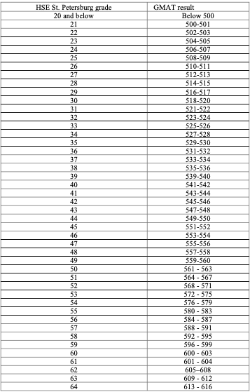

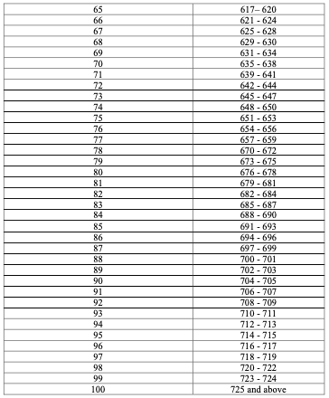

GMAT (Graduate Management Admission Test) – Quantitative part
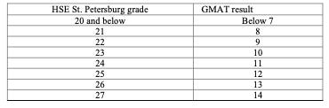
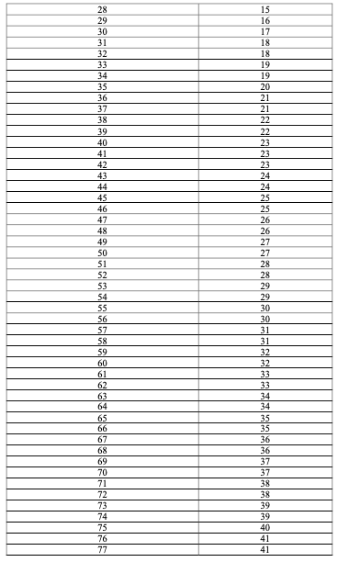
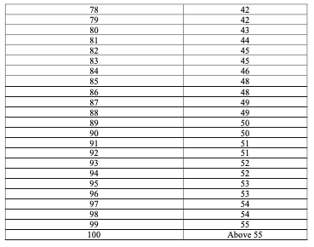

GRE Subject Test in Mathematics
