Rules for preparing the bachelor’s thesis

1. General requirements for the bachelor’s thesis
The bachelor’s thesis must be written in English.
The bachelor’s thesis may be completed either individually or in groups of 2 or 3 students. The structure of the bachelor’s thesis and required length is the same for individual and group projects.
The recommended length of the bachelor’s thesis is 8,000 to 15,000 words.
The format of the bachelor’s thesis must correspond to the requirements given in this document.
The bachelor’s thesis may be written in one of three formats:
- Article format (research article / manuscript) – the thesis should be in the form of a research article and should be based on empirical research that attempts to obtain new knowledge about the structure, properties or empirical regularities of the object of the research. Students who write their thesis in the form of a research article must submit together with the thesis a copy of the author guidelines for the relevant journal. In most cases, these guidelines are available on the journal’s website. For the format of the thesis, students may not use a journal included in the blacklist of HSE University: https://scientometrics.hse.ru/en/blacklist/. In case of any contradictions between author guidelines provided by the journal and the requirements listed in this document, the journal guidelines have the second priority.
- Consulting format – developing a solution to a practical problem based on a comprehensive analysis of an active company. The formal company request is required to conduct this format of bachelor’s thesis. This format may be used only if the project of the thesis is based on and proposed by someone from business and is formally approved by both the student’s academic supervisor and the academic council of the programme “International Business and Management”. Such a format involves analysing a problematic situation, using a clear-cut research framework, developing a set of tools that can be used to solve the challenges in this situation and making recommendations for how to use these tools to solve these challenges. With this format, the thesis is required to have practical significance (i.e. managerial application) and be based on the analysis of an active case company.
- Within the consulting format, students may write their bachelor’s theses in the format of “Start-up as a thesis”. Formal documentation confirming the start of new business is required.

Timeline for thesis preparation
 | Stage of preparing the bachelor’s thesis | Deadline
1. | Research proposal: the proposed plan should be presented and sent to the research advisor | December 15
2. | The second submission of the research proposal to the research advisor in case of a major revision | December 25
3. | The final topic of the thesis should be approved by the supervisor | March 1
4. | The first draft of the bachelor’s thesis to be sent to the research advisor | April 1
5. | The final text of the bachelor’s thesis to be sent to the research advisor | June 1

2. Bachelor’s thesis structure requirements
The bachelor’s thesis consists of the following parts:
- abstract
- introduction
- main body
- conclusion
- references
- appendices, if relevant
The structure of the work for three different formats is the following:

Table 1. Recommendations for the structure of a bachelor’s thesis in article format.
Component | Recommended %,  as a % of the entire thesis
Introduction, including research question(s) | 15
Literature review | 20
Methods and Data | 25
Results | 15
Discussion | 15
Conclusion | 10

Table 2. Recommendations for the thesis structure in a consulting format.
Component | Recommended %,  as a % of the entire thesis
Introduction | 10
Literature review | 25
Analysis of the situation | 30
Project section | 25
Conclusion | 10

Table 3. Recommendations for the structure of a bachelor’s thesis in a start-up format.
Component | Recommended %,  as a % of the entire thesis
Introduction | 15
Analytical part | 30
Project part | 40
Conclusion | 15

The Abstract is a short description of the purpose, methods, main results and contribution of the bachelor’s thesis. The abstract should be between 200-300 words. The abstract should be placed before the introduction to the main body of the bachelor’s thesis.
The Introduction should contain the following:
- research background and motivation (how the thesis differs from prior research on the topic: the extent to which prior studies have analysed the topic of the thesis, and what is new about the analyses in the thesis);
- the relevance of the research problem to the specified context;
- a research question grounded in the specified research context;
- the methods that will be used to address the research question;
- the proposed managerial application and scientific contribution;
- the outline of the subsequent sections (1 paragraph in the end of the introduction).

After the Introduction, research background, research motivation, research question(s), practical significance and scientific contribution of the thesis relative to prior studies should be clear.
The practical significance and scientific contribution of the thesis relates to the importance of the solution for the research problem (“so what” question). When discussing the practical significance, the thesis should contain a discussion of (1) the importance of the analysed problem for companies and\or policy makers; (2) the potential contribution of the results of the thesis to increasing the efficacy of organisations, etc. When discussing scientific contribution, the thesis should outline the academic value of the research: (1) within which research streams the thesis is positioned, i.e. what is already known from the extant research on the topic and (2) the way the thesis advances the knowledge on the chosen topic.
The last paragraph of the introduction section should contain an outline of all of the sections in the document.
The structure and content of the Main body of the bachelor’s thesis depend on whether the thesis is in article format or a consulting format.
Regardless of the format, the final section is the Conclusion. In this section, students are required to summarise the theoretical and empirical parts of the thesis and to outline potential directions for future research.
The conclusion should contain the following:
- a brief summary of the conducted analysis based on the research focus;
- a more generic (as opposed to results section) summary of the main results;
- theoretical contribution of the research together with the proposed managerial application of the research results, e.g., to the creation of new knowledge, to helping organisations, countries, economies operate in an effective manner, etc.;
- the primary limitations of the thesis, and how these limitations could be overcome in future research;
- whether using different assumptions, methodologies, etc. could lead to different results;
- the way(s) the topic of this research could be further developed in future research.

The total number of conclusions can differ between theses but should be between at least 3 to 5. With more than 5 conclusions, it could be useful to impose additional structure on these conclusions – for example, by placing conclusions into groups.
The conclusion should not be a summary of the prior sections of the research. The conclusion section should start with a brief summary of the conducted analysis and the research aim and provide a summary of the main results, emphasise the correspondence of the results with the stated research question and theoretical foundation.
After the conclusion, the thesis should include a Reference list. Each reference included in the reference list must be cited in the text. The reference list should consist of original sources written in English and include at least 25 academic articles (normative acts are not regarded as either a monograph or a scientific article).
In the bachelor’s thesis for International Business and Management programme, the preferred type of source is academic papers published in English in top tier journals from Academic journal guide of the Association of Business Schools.
The reference list contains continuous numbering, using Arabic letters. Foreign sources are placed in alphabetical order at the end of the list (see 4.3. for examples).
The reference list can be based on either the Harvard reference system or the APA reference style.
The Appendices are included after the reference list. The objective of including material in the appendices is to avoid including in the text calculations, data, etc. that contain information that is relevant but not essential for the main research problem of the thesis. Each appendix should begin on a new page, have its own heading and be mentioned in the Thesis main body (see 4.4. for details).

3. Specific requirements to bachelor’s thesis formats

3.1. Bachelor’s thesis in article format
The main body of the bachelor’s thesis in article format should consist of at least four sections (Literature review; Methods and Data; Results; Discussion).
In the Literature review, students should demonstrate the ability to do the following:
- to summarise and analyse in a critical manner theory relevant for the issue the thesis focuses on;
- to identify the most important theoretical issues relevant for the topic of the thesis;
- to use theory to develop a foundation for the empirical analyses in the thesis that they use to evaluate the obtained results against the chosen theoretical lenses;
- formulate operationable hypotheses based on the relevant academic articles.

In the Literature review, students should do the following:
- specify the prior research that is the basis for the research question in the thesis;
- identify relevant problems that have not been solved in full in prior research;
- define the main concepts, theory, etc. required to address the research problem;
- formulate hypotheses for further testing.

In most cases, the bachelor’s thesis focuses on a narrow research question. Hence, the overview of prior literature is based only on the relevant research question, not on the entire theme in general. Students should not discuss prior research that has only an indirect relationship to the research question.
The literature review should be based on only the most relevant and fundamental prior research in top tier academic journals (see 4.3). In the literature review, references to textbooks are not allowed. The literature review should not consist of only a list of previous studies and the primary conclusions of these studies. In the literature review, students are required to organise prior studies in a systematic way, to identify similarities and differences in these studies and justify the relevance of each prior study for the thesis. When different prior studies come to different conclusions, students should summarise these different conclusions and discuss which conclusion they agree with, using logical arguments and reasoning.
In the end of the literature review section, students should specify the relationships between concepts to be analysed based on the links to extant research for each hypothesis. justify and develop their hypotheses. The students should introduce the corresponding research streams for each hypothesis before it is formulated by starting with a critical review of the studies focusing on the relationship of interest. After outlining the main directions of the academic discussion on the relationship of interest, students formulate the hypothesis. This should be done separately for each hypothesis to adhere to the generally accepted standards for hypotheses’ development in academic journals of decent quality.
Examples of issues that should be discussed in this section include the following:
- what articles are important to highlight, and how have these articles contributed to the development of the relationships between the concepts the thesis is focused on?
- what issues do prior studies disagree on?
- how is it possible to develop further the research question – i.e., what issues have not been solved in full in prior research?

The literature review is the main pillar for the future development of the thesis as it facilitates the choice of methodology and the specific research question that the thesis will focus on. Most importantly it sets the boundaries for the discussion section, where students must discuss the obtained results in the context of the chosen theoretical lenses and provide detailed explanations of the underlying theoretical reasons for the results. The literature review section must supply a research framework of the thesis after the hypotheses development.
For the article format the Methods and Data section must include:
- the specification of the research design used to address the research question;
- a description of the methods and procedures used to analyse data and of the statistical software used to analyse data;
- the justification for the choice of a particular methodology;
- a description of the process used to collect data, data sources, the type of sampling and the representativeness of the sample;
- a description of the data collected in each stage of the research process;
- a description of the tools used (tool specific files and logs should be included as an attachment – e.g. a Do-file from Stata);

Examples of issues that should be discussed in this section include the following:
- what is the connection of this section and the theoretical foundation?
- are the proposed methods sufficient to analyse the stated research question and why?
- do the data and sampling approach used address the stated research context?
- how will the methods from the prior point be used?
- what data will be used, and why?
- how will data be gathered and analysed?

The objective of this section is to justify why the chosen data and methods can be used to address the research question. In this section, it is necessary to present a convincing argument that the data and methods are relevant for the research question and to discuss the limitations of the methods and data that are used.
Results section presents the results of the empirical analyses. This section should contain an objective description of the results. This section should not contain a critical analysis or a discussion of conclusions that could be drawn based on these results. Based on the results of this section, it should be clear which hypotheses are statistically significant, which hypotheses are rejected, which hypotheses are confirmed. In addition, based on the results of this section, the quality of the model should be clear. It is highly recommended to present the results using an empirical framework as an addition to tables, graphs, diagrams.
All of the source files, including files with algorithms and code, that the results are based on should be included as an attachment – either in paper or in electronic form.
Discussion section should provide an explanation for each result generated with a detailed reasoning based on the adopted theoretical lenses. A discussion of the obtained results should include references to extant research in the field and build up the core of the contribution of the research.
Examples of issues that should be discussed in this section include the following:
- what are the primary results of the research?
- how are these results similar to and different from the results of prior studies?
- how could these results be interpreted based on the chosen theoretical foundation and\or alternative angles from the extant research?

3.2. Bachelor’s thesis in a consulting format
The main body of the theses written in a consulting format should include the following parts:
The Literature review section should include all the elements of the literature review section for article format (see 2.1) which are relevant and can be attributed to the analysed problem.
The Analytical section of the thesis should contain a general description of the object of the thesis, an analysis of the relevant problem and data developed with modern techniques described in the theoretical foundation of the thesis. In addition, this section should contain different indicators related to the characteristics of the research object. This section should also contain a justification of the subsequent development of the thesis.
This section should start with a description of the object researched in the thesis and a justification of why it is necessary to examine this object. Relevant reasons include a decline in the market, financial or organisational position of the object, potential new developments in the object, the initiation of new projects, etc.
Next, this section should include a comprehensive analysis, starting from the formulation of the research programme. The research programme includes the different stages of analysis and the definition of instruments and statistical data that will be used in each stage of the analyses.
This section should conclude with conclusions and recommendations for further measures that could be taken. These further measures are the basis for the third part of the bachelor’s thesis.
The Project section is the central part of this format and should contain the development of a set of measures for the solution of the stated problem as well as forecasts, with supporting calculations, for the results of the application of these measures. The basic requirement for this section is to present a comprehensive, thorough and complete solution to the problem studied in the thesis. This section should not include only general recommendations or general suggestions for further development. All of the suggestions and recommendations should be developed to the stage of implementation and should have a concrete character. The thesis should show how these measures affect indicators relevant for the firm, organisation, etc.
The guidelines for the Introduction and Conclusion sections are found in section 1.

3.3. Bachelor’s thesis in a start-up format
The results of a thesis prepared using the format “Start-up as a thesis” are a legitimate entrepreneurial project that involves the creation and circulation of a product (services) acknowledged by a client as valuable. Bachelor’s theses written in the format “Start-up as a thesis” should have at least two of these three signs:
- the presence of legally valid documents that confirm the independence of the project (signed documents, including the founding documents; articles of association, in the case of the creation of a legal entity; contracts with purchasers or suppliers; licenses, patents, permissions, and so on).
- the presence of verified reports about the provision of services, the execution of work, the provision of goods, sales and cash flows of the project, etc.
- government registration of a legal entity or individual entrepreneur or the registration of a project as a spin-off in an organisation with the participation of the National Research University Higher School of Economics.

The supervisor for bachelor’s theses written in the format “Start-up as a thesis” is appointed by a professor with experience as an academic supervisor for and with practical experience in managing a business and recruiting consultants (mentors) for projects in the sphere of activity relevant for the project.
The defence (presentation) of the bachelor’s thesis may be held in Russian or in English.
In the analytical part, the student identifies a research problem; presents the results of testing a business idea; presents research on the market segment based on relevant instruments of analysis and with a justification of these instruments; justifies the business model; and forms the fundamental requirements for the business and for the product for entering onto the market.
The project part of the bachelor’s thesis includes such issues as the objective of the project, the tasks that are necessary to achieve these objectives, the risks of the project, the participants in the project and other information relevant for the project; and a completed business plan developed in accordance with international or Russian standards.
In addition to required calculations, tables and graphs, the appendix to the thesis should contain information in the form of scans (copies) of documents that confirm that the thesis has the signs, defined under point 3, of a bachelor’s thesis in the format “Start-up as a thesis”.
Bachelor’s theses may be written in the format “Start-up as a thesis” only if authorised by the academic council of the programme Management. Students who wish to write a thesis in the format “Start-up of a thesis” should submit by email to the academic director of the programme Management a letter with information about the project and the student’s role in the start-up. In addition, students should submit by email to the academic director of the programme Management documents that confirm that the thesis has the signs, defined under point 3, of a bachelor’s thesis in the format “Start-up as a thesis”.
To assess students’ progress in the preparation of abstracts, the Centre for Innovative Entrepreneurship NRU HSE can arrange two pitch sessions for a start-up, with the involvement of experts. The guidelines for the Introduction and Conclusion sections are found in section 1.

4. Technical requirements and formatting of the bachelor’s thesis

4.1. Technical requirements
The bachelor’s thesis should be printed on standard sheets of paper using the format А4. The four sides of the pages should have the following margins: left margin – 35 mm; right margin– not less than 10 mm; upper and lower margins – not less than 20 mm. Each page should have approximately 2,000 characters.
Line spacing:
- Main text – 1.5
- Reference list – 1.5
- Tables, figures and graphs – 1
- Footnotes – 1

Font – Times New Roman. Other fonts are not allowed.
Font size:
- Main text – 12
- Reference list – 12
- Shorter tables, figures, graphs and equations – 12
- Larger tables – not less than 10
- Footnotes – 10
- Font colour – black. Drawings and graphs may be presented in colour.
- Alignment:
- Main text, reference list, footnotes, abstract and keywords – justified
- Headings – centred

Each new section should begin on a new page. This same rule applies to the other main parts of the thesis (introduction, conclusion, reference list, appendices, etc.). Paragraphs should be indented at 1.25 cm. The main text should be aligned by width. A subsection may be started on the current page if at least five lines of text (not including the name of the subsection) from this subsection would be on the current page.
Pages should be numbered starting from the title page, but the page number should be shown starting only from the second page – i.e., on the title page, the page number should not be shown. Page numbers should be shown on the bottom of each page, either in the centre or on the right, with no period.
The bachelor’s thesis begins with the title page. The title page provides information about the academic institution where the work was completed; the title of the thesis; the type of thesis; the last name, initials and group of the student; the last name, initials and academic degree and position of the scientific supervisor; and the city where and year in the work was conducted.
The second page of the thesis contains the abstract.
To highlight certain terms or formulas, the use of either bold or italics is permitted. Underlined text (example) is not allowed. Moreover, only one of either bold or italics may be used at a time – the use of bold and italics (example) in one term is not allowed.
The text of the bachelor’s thesis may contain abbreviations – both commonly used abbreviations (e.g., the USA for the United States of America) and abbreviations introduced by the author. In both cases, in the first mention of the abbreviation, the word or words should be written in full, with the abbreviation given in parentheses. For subsequent references, the abbreviation may be used without reference to the full word or words.

4.2. Formulas
If necessary, the bachelor’s thesis may contain formulas.
Formulas are placed either on a separate line, centred, or within the text. It is recommended to place in the text short, simple formulas. These formulas should not be numbered. More important formulas, or formulas that are longer are more complex (e.g., formulas that involve differentiation, integration, etc.), should be placed on a separate line, centred and numbered.
Formulas should be numbered consecutively throughout the thesis. A period is not placed after the number of the formulas. The number is written in Arabic numbering, in parentheses, to the right of the formula.
The meaning of symbols, coefficients, etc. in a given formula should be given in the text below the formula, if these symbols, coefficients, etc. have not been explained earlier in the text. Each symbol should be shown on a separate line, in the same sequence as in the formula.
Example:
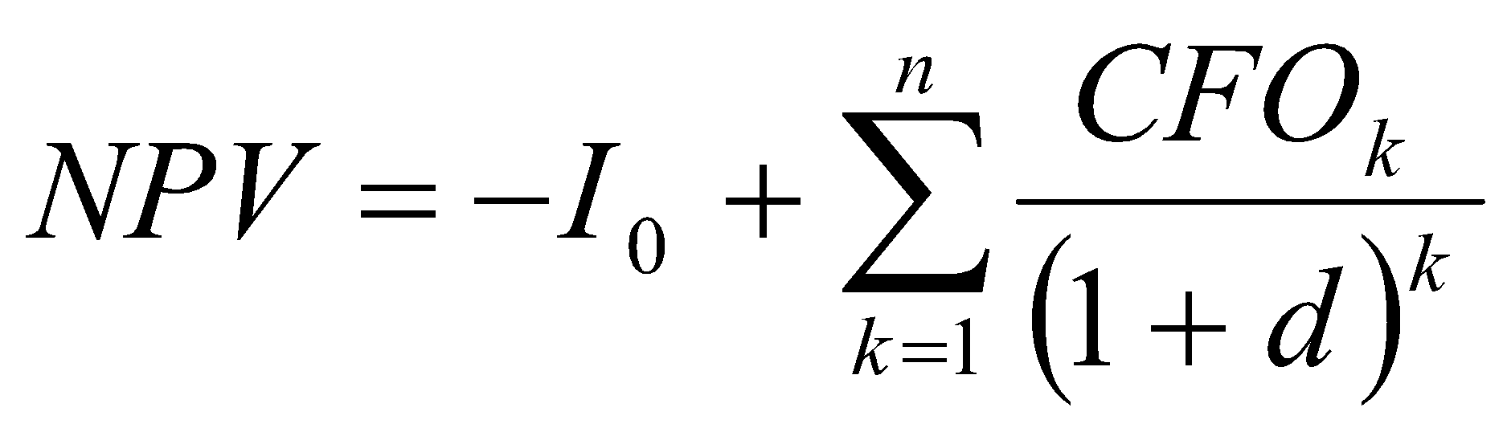, | (1)
where: 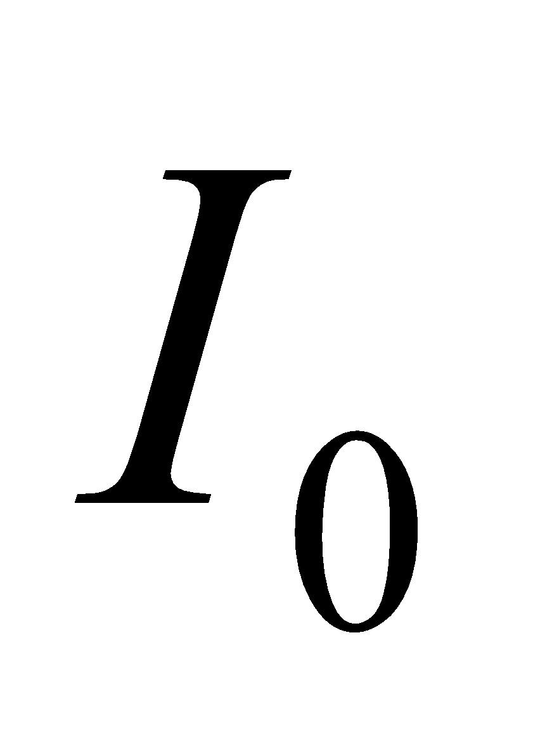 – the initial investment;
n – the number of periods in the project;
– cash flows during the period;
d – the discount rate.
Two lines should be placed between the end of the list of symbols, coefficients, etc. and the main text.

4.3. References
4.3.1 Citation in text
Please ensure that every reference cited in the text is also present in the reference list (and vice versa). Any references cited in the thesis must be given in full. Citations in the text should follow the referencing style used by the Harvard reference system or the APA reference style.
Examples of in-text citations using the APA Style:
1. Single author: the author's name (without initials, unless there is ambiguity) and the year of publication. An example: (Kumar, 2020);
2. Two authors: both authors' names and the year of publication. An example: (Kumar & Kumar, 2020);
3. Three or more authors: first author's name followed by 'et al.' and the year of publication. An example: (Kumar et al., 2020).
Citations may be made directly (or parenthetically). Groups of references should be listed first alphabetically, and then chronologically. Example: "as demonstrated (Allan, 1996a, 1996b, 1999; Allan & Jones, 1995). Kramer et al. (2000) have recently shown ...."

4.3.2 Reference list
The reference list is placed at the end of the thesis.
The reference list contains continuous numbering, using Arabic letters. Foreign sources are placed in alphabetical order at the end of the list. The reference list can be based on either the Harvard reference system or the APA reference style.
Examples using the APA Style:
- Articles in journals:
Hsu, Y.-S., Chen, Y.-P., Chiang, F. F. T., & Shaffer, M. A. (2021). It takes two to tango: Knowledge transfer between expatriates and host country nationals. Human Resource Management, 1– 24.
Colquitt, J. A., & Zapata-Phelan, C. P. (2007). Trends in theory building and theory testing: A five-decade study of the Academy of Management Journal. Academy of management journal, 50(6), 1281-1303.
- Sources from the internet:
Krivkovich A., Starikova I., Robinson K., Valentino R., and Yee L. (2021). Women in the workplace. McKinsey report. Available from: [https://www.mckinsey.com/featured- insights/diversity-and-inclusion/women-in-the-workplace].
OECD (2020), COVID-19, crises and fragility, OECD Policy Responses to Coronavirus, OECD Publishing, Paris. Available from: [https://doi.org/10.1787/2f17a262-en].
- Books, monographs:
Chinyong Liow, J., Liu, H., & Xue, G. (Eds.). (2021). Research Handbook on the Belt and Road Initiative. Edward Elgar Publishing.
Pan, Z. (2015). Global Value Chains and Production Networks: State-Business Relations and Complexity in Economic Crises. Chapel Hill, NC: University of North Carolina at Chapel Hill Graduate School. https://doi.org/10.17615/8zkc-pr75

4.4. Appendix
The appendix is the final part of the bachelor’s thesis. The appendix contains supplemental material that is helpful in understanding the main text. The appendix may contain many different types of contain – e.g., extracts from reports, copies from documents, individual parts of instructions, etc. The appendix can include text tables, graphs, etc. The appendix is included after the reference list.
Each appendix should begin with a new page, with ‘Appendix’ indicated in the upper-right corner of the page. ‘Appendix’ should be followed by the number of the appendix, in Arabic numbering. Each appendix should contain a heading that describes the content of the appendix. The title of the appendix should be in lowercase letters, except for the first letter of the first word of the appendix, and should be placed on a separate line.
The appendices should contain consecutive page numbers, continuing from the page numbers in the main text and reference list. Appendices should be ordered based on the order of each appendix in the text – e.g., the appendix referred to first in the text is Appendix 1; the appendix referred to second is Appendix 2; etc.
If the appendix contains multiple connected structural elements (e.g., multiple tables, multiple illustrations), these elements should be numbered (e.g., Table 1, Table 2, etc.). Each structural element should contain its own heading and name.

5. Defence of the bachelor’s thesis
For theses written in article format, the presentation must be based on the submitted thesis text, the final evaluation of the defence shall be based on these criteria:
- Justification of research motivation and the research framework – 20%
- Relevance of the chosen theoretical foundation and the methodology – 30%
- Clear and validated results – 20%
- The quality of the discussion and conclusion sections with well-developed scientific contributions and managerial implications – 20%
- Responses to questions – 10%
For theses written in article format, the final evaluation of the defence is:
Criterion (1) x 0.20 + Criterion (2) x 0.30 + Criterion (3) x 0.20 + Criterion (4) x 0.20 + Criterion (5) x 0.10

For theses that are written in a consulting format the defence is organised only after approving all the necessary documents from the case company. The final evaluation of the defence shall be based on these criteria:
- Justification of the project – 10%
- Research framework – 10%
- Development of the solution to the project – 50%
- Results and conclusions – 20%
- Responses to questions – 10%
For theses written in a consulting format, the final evaluation of the defence is:
Criterion (1) x 0.10 + Criterion (2) x 0.10 + Criterion (3) x 0.50 + Criterion (4) x 0.20 + Criterion (5) x 0.10

For theses that are written in a start-up format the defence is organised only after approving all the necessary documents. The final evaluation of the defence shall be based on these criteria:
- Justification of the business idea – 20%
- Development of the business idea – 50%
- Results and conclusions – 20%
- Responses to questions – 10%
For theses written in a start-up format, the final evaluation of the defence is:
Criterion (1) x 0.20 + Criterion (2) x 0.50 + Criterion (3) x 0.20 + Criterion (4) x 0.10

In each format, each member of the commission shall evaluate students on each criterion from a scale of 1-10. The evaluation for each criterion is the average evaluation from the members of the commission.
Following the defence, together with the final evaluation for the defence, the evaluation for each criterion could be disclosed to the student upon request. Only the average evaluation for each criterion could be disclosed; the individual evaluations of each member of the commission shall not be disclosed.
The defence of the bachelor’s thesis is evaluated on a five-point and ten-point scale. The evaluation is entered into the protocol of the meeting of the commission that includes the chairperson and members of the State Examination Commission (SEC).
If a student receives the evaluation ‘Unsatisfactory’ for the defence of the bachelor’s thesis, the repeat defence will be conducted in accordance with the Rules for the final state attestation of graduates of the state university Higher School of Economics.
If a student is not present at the defence because of a valid reason, the defence will be conducted in accordance with the Rules for the final state attestation of graduates of the state university Higher School of Economics.
Based on the results of the defence of the bachelor’s thesis, the SEC will make a decision about whether to grant the student the degree in the programme “International Business and Management” and about the issuance of a document for higher education.

For a list of relevant journals, please use the websites https://charteredabs.org/academic-journal-guide-2021-view https://scientometrics.hse.ru/goodjournals/
https://www.emeraldgrouppublishing.com/how-to/authoring-editing-reviewing/write-article-abstract
https://charteredabs.org/academic-journal-guide-2021-view
http://www.emeraldgrouppublishing.com/authors/guides/write/harvard.htm
http://www.apastyle.org/index.aspx
http://www.emeraldgrouppublishing.com/authors/guides/write/harvard.htm
http://www.apastyle.org/index.aspx
http://www.emeraldgrouppublishing.com/authors/guides/write/harvard.htm
http://www.apastyle.org/index.aspx

