****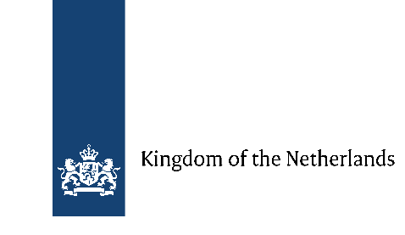 **Program of   
Open lectures on implementation of Istanbul Convention   
and Prevention of Domestic Violence against women.   
Experience of Norway and Netherlands**

|  |  |
| --- | --- |
| 12:30 – 12:50 | ***Registration*** |
| 12:50 – 13:00 | ***Welcome speeches***:   * Representative of HSE Campus in Saint-Petersburg; * Dag Malmer Halvorsen, Norwegian Consul General in St. Petersburg; * Lionel Veer, Dutch Consul General in St. Petersburg. |
| 13:00 – 13:30 | Lionel Veer, Dutch Consul General in St. Petersburg. Human Rights Ambassador in Netherlands (2010-2014), Ambassador, Permanent Delegate to UNESCO (2014-2018).  “***Overview of the Implementation of the Istanbul Convention in Netherlands”*** |
| 13:30 – 14:10 | Peter Wille, director of Norwegian National Human Rights institution.  *“****The human rights obligations to combat violence against women and domestic violence”*** |
| 14:10 – 14:50 | Kolokatsi Elpiniki, Tutor European criminal law and Substantive and procedural criminal law at Maastricht University (part-time), attorney at law.  ***Implementation of Dutch legislation in order to prevent domestic violence*** |
| 14:50 – 15:10 | Coffee-break |
| 15:10 – 15:50 | Solveig Bergman, Dr.Soc.Sc., Norwegian Centre for violence and traumatic studies  ***“Prevention of domestic violence and protection of victims of domestic violence: Work of state institutions and the practice of NGOs”*** |
| 15:50 – 16:30 | Senior adviser of the Ministry for Health and Sport in Netherlands.  ***“Rehabilitation policy of victims of domestic violence in Netherlands”*** |
| 16:30 – 17:10 | Sara Bondø, Information Officer Crisis Centre Secretariat.  “**The provision of a good comprehensive crises centers services**” |