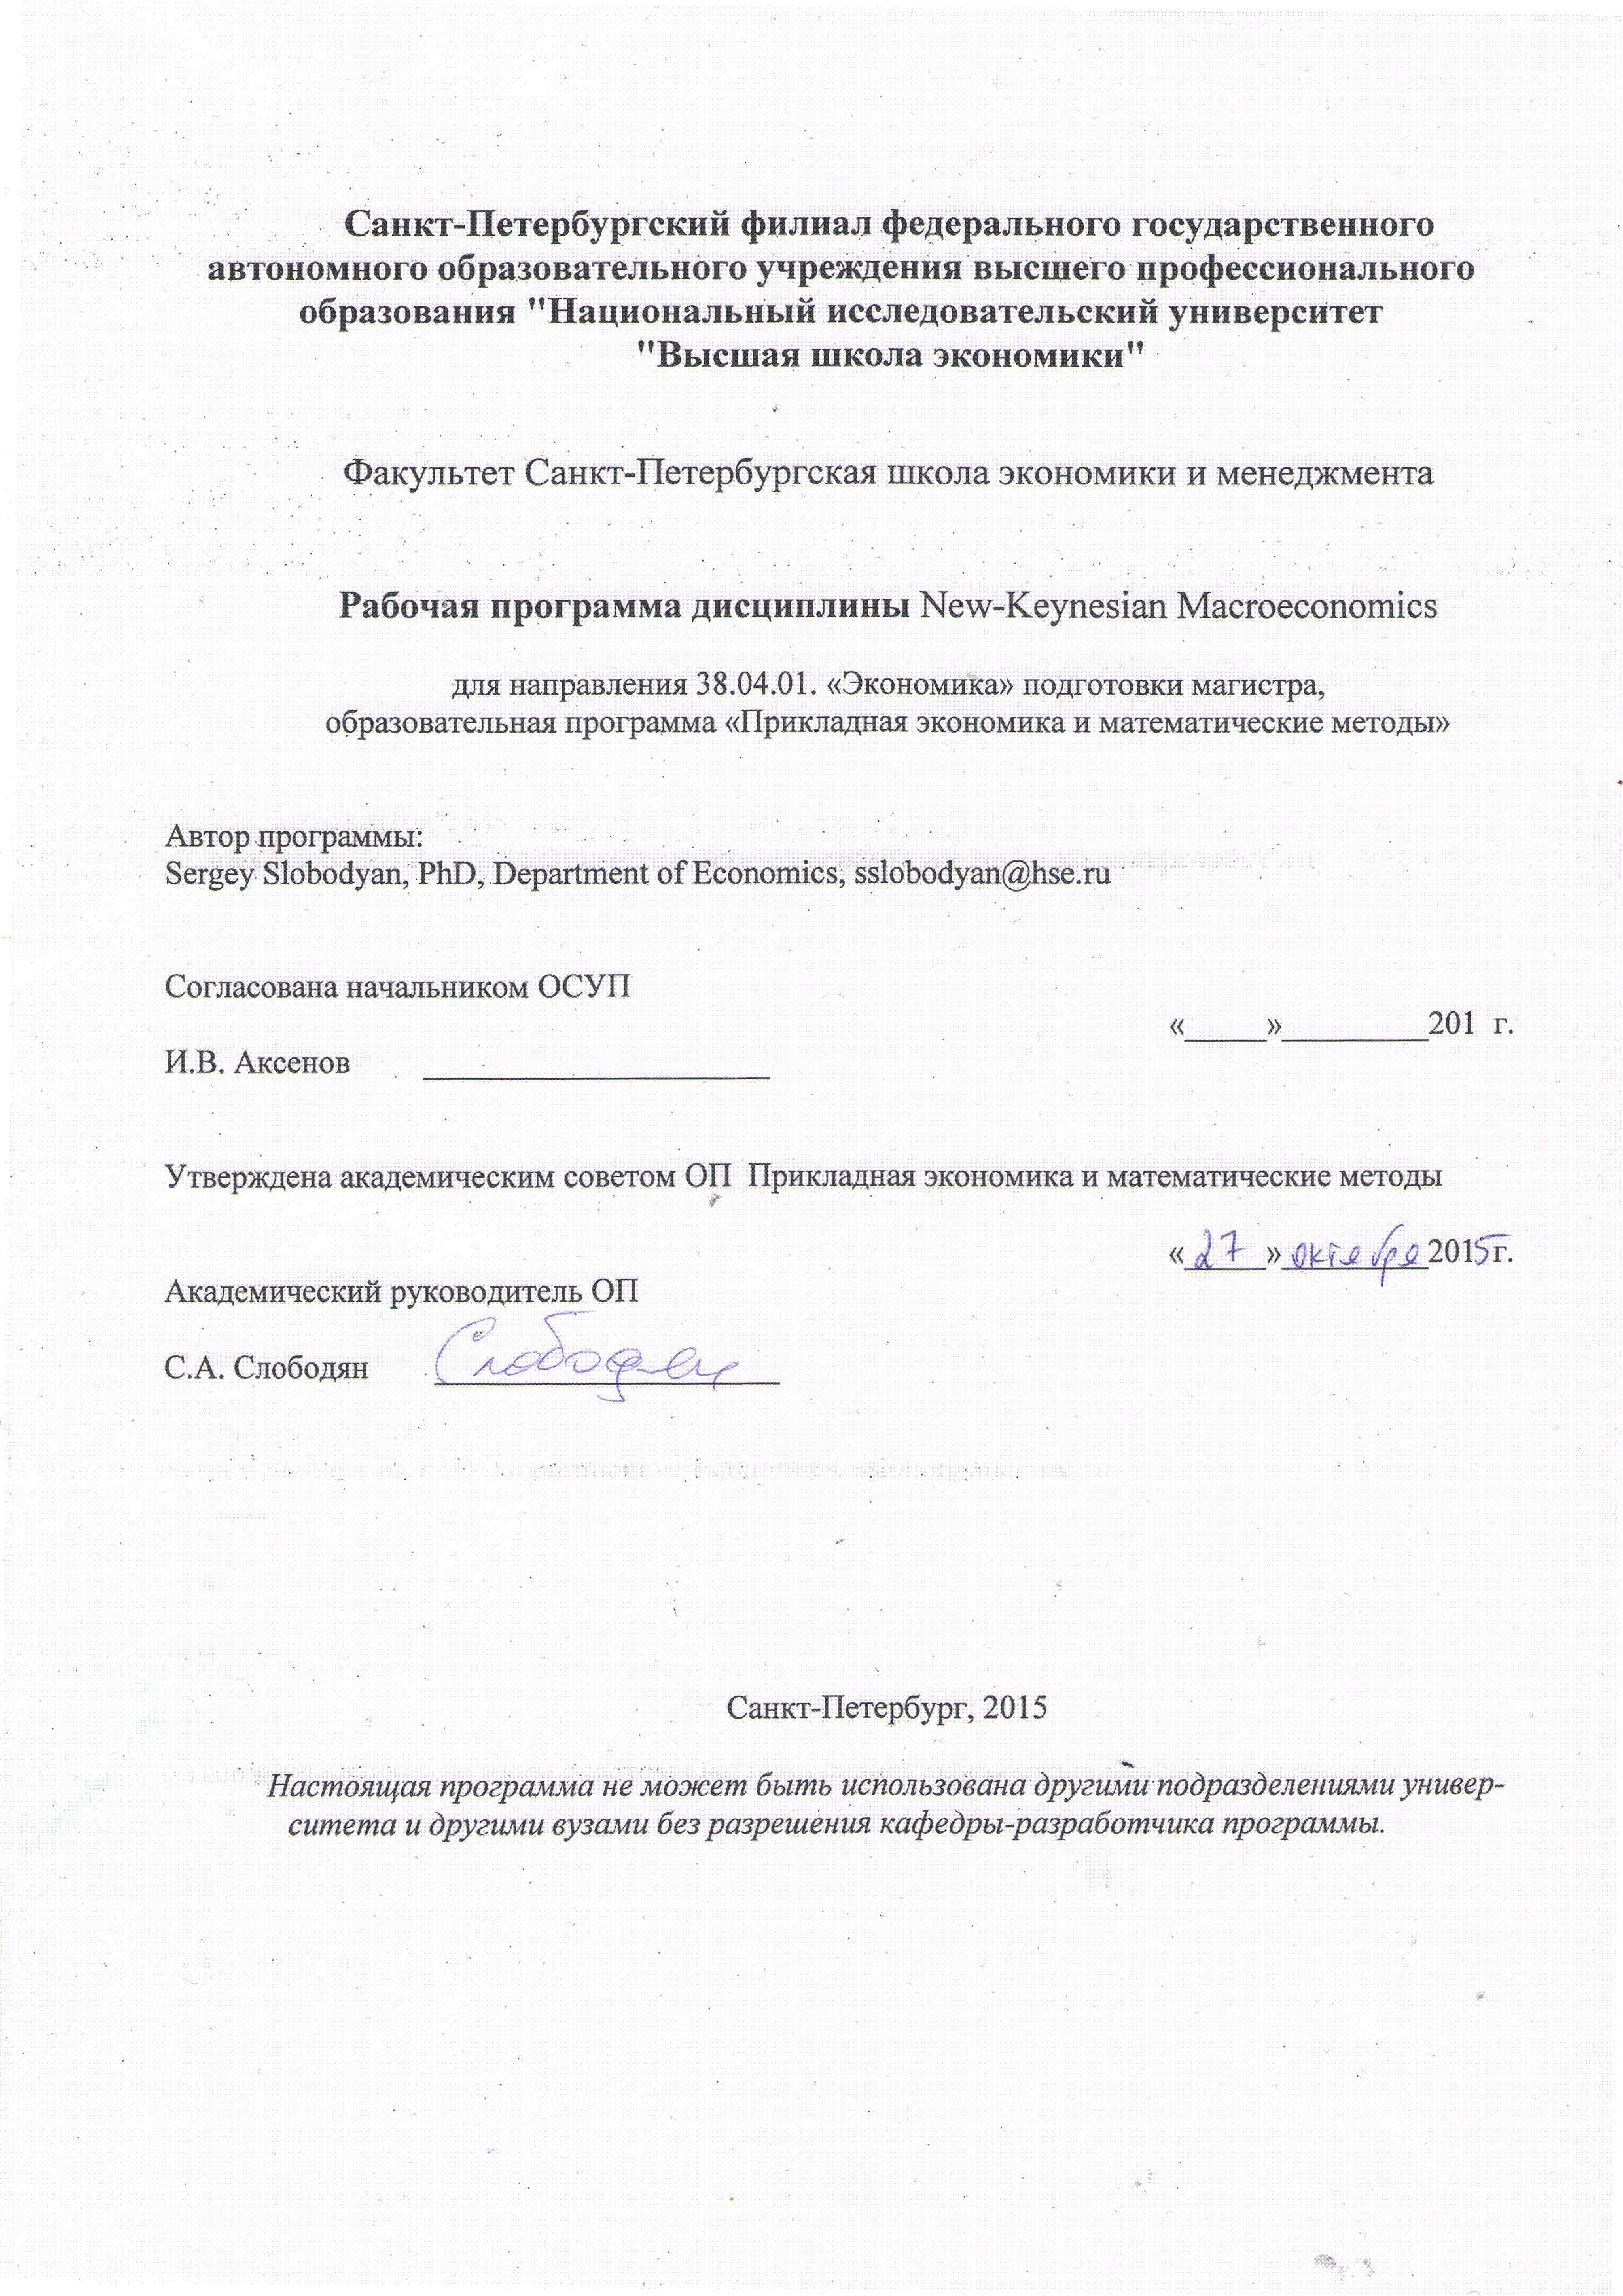

Course description

- Course name, ECTS, quarter/semester, contact hours

New-Keynesian Macroeconomics, 2nd quarter, 3 ECTS, 36 Contact hours

- Author of the course

Sergey Slobodyan, PhD, Department of Economics

- Outline

This course will introduce a basic New Keynesian model, extend the basic model to account for unemployment and see how this model explains recoveries after recessions, introduce the problem of optimal monetary policy in the basic NK framework, and teach you to simulate and estimate DSGE models using DYNARE. If time permits, we will discuss the workhorse model of modern monetary policy – Smets and Wouters / CEE model.Adaptive learning in estimated DSGE models and desirability of inflation targeting are desirable topics which might be skipped for lack of time.
- Literature

Main Text:
Gali, J. (2015). Monetary Policy, Inflation, and the Business Cycle.An Introduction to the New Keynesian Framework.Princeton University Press, 2nd edition.http://crei.cat/people/gali/monograph.html
This is the main textbook for this class. My lecture slides will be mostly following the book. The author’s own slides are available from the URL given above.
Additional Texts:
Lim, G. C. and Paul D. McNelis (2008) Computational Macroeconomics for the Open Economy.MIT Press.
This text considers mostly including open economy NK macro models that are more sophisticated than the ones we will study in this course, and uses numerical methods that go beyond log-linearization to solve these models. For computationally and macroeconomically-minded.
McCandles, George (2008). The ABCs of RBCs: An Introduction to Dynamic Macroeconomic Models. Cambridge: Harvard University Press, 2008.

This text could be used to refresh (or learn) the most basic neo-classical model and the straightforward numerical methods of solving it (value function iterations). Typically, this book is used in a dynamic macroeconomic course that precedes the one we study.

Optional reading:

Walsh, Carl. E. (2010) Monetary Theory and Policy. MIT Press, 3rd edition.http://people.ucsc.edu/~walshc/mtp3e/

The best textbook introducing a wide variety of monetary policy-related issues, including a deep discussion of optimal monetary policy and time inconsistency of monetary policy, topics that will be only slightly touched in this course.

Woodford, Michael. (2003) Interest and Prices.PrincetonUniversityPress.

This is the book on monetary policy which introduced a canonical NK model and all the major topics that were used in later monetary policy literature. The book is very dense, and I wouldn’t call it a textbook. This is a compendium of basic knowledge, somewhat dated at the moment.

AdaptiveLearningtexts:

Evans, G.W. and S. Honkapohja (2001).Learning and expectations in macroeconomics.PrincetonUniversityPress.

This book has the status similar to Woodford’s for Adaptive Learning literature. As the flowering of the AL literature as well as its fruitful movement towards monetary policy topics has happened later than 2001, this text is mostly a collection of early results plus theoretical background on adaptive learning.

Evans, G.W. and S. Honkapohja (1999).Learning dynamics, in Handbook of Macroeconomics, ch.7.

To a large extent this chapter was an advance advertisement for the Learning and expectations in macroeconomics book. Shorter and less technical read for those unwilling to struggle through the 2001 book.

Workhorse NK Model for Policy Analysis:

Christiano, L.J., M. Eichenbaum, and C.L. Evans (2005).“Nominal Rigidities and the Dynamic Effects of a Shock to Monetary Policy”. Journal of Political Economy, 113(1), p. 1-45.

Smets, F., and R. Wouters (2007).“Shocks and Frictions in US Business Cycles: A Bayesian DSGE Approach”.American Economic Review 97(3), p. 586-606.

These two papers describe the two varieties of the most widely cited NK model which led e to broad popularity of DSGE models in central banking and academic monetary policy circles.

Unemployment in NK Models:

Gali, J. (2011). Unemployment Fluctuations and Stabilization Policies.A New Keynesian Perspective.The MIT Press.

This book, published in the series Zeuthen lectures by the MIT press, contains an elegant restatement of the basic NK model which allows introduction of involuntary unemployment.

Gali, J., F. Smets, and R. Wouters (2011).“Unemployment in an Estimated New Keynesian Model”.NBER Working Paper 17084.

Estimated version of Gali (2011).

DYNARE

http://www.dynare.org/

DYNARE is a software platform for solving, simulating, and estimating a wide class of economic models, in particular dynamic stochastic general equilibrium (DSGE) and overlapping generations (OLG) models, under rational expectations and purely backward-looking. DYNARE has grown into a widely used tool which is indispensable for anyone engaged in writing modern macroeconomic papers or for practitioners of macroeconomic policy such as Central Bank staff members. DYNARE is a free software which runs on MATLAB or Octave, a free clone of MATLAB.

- Structure and content
- The Basic New Keynesian Framework for Studying Monetary Policy – Models with Nominal Rigidities.
GaliCh 3. 2 lectures.
- Monetary Policy Design in the Basic New Keynesian Model.
GaliCh 4. 2 lectures.
- A Model with Sticky Wages and Prices and Monetary Policy Trade-Offs.
GaliCh 5-6. 3 lectures.
- S&W and CEE models.
Papers.2 lectures.
- Unemployment in the New Keynesian Model.
GaliCh7, papers.2 lectures.
- Adaptive Learning or reserved.
1 lecture.

- Prerequisites

Mathematics for Economists, undergraduate-level Macroeconomics.

- Assessment

60% - final exam, 30% - seminar involvement, 10% - class participation and in-class assessment.

