Application
The Summer School has a restricted access. Applicants are kindly requested to fill in the attached application form, and mail it – together with the documents listed in the tender notice - to: summerschool.digi@unibs.it or fax it to +39 (030) 2989604.
Applicants will be selected by a Committee appointed by the Faculty. Successful applicants shall be notified within 20 days before the beginning of the courses. As for the selection criteria, please see the tender notice.

Tuition Fees
Participation is free for students regularly enrolled at University;
Post graduate students: €. 80,00;
Lawyers: €. 350,00.
As for payments procedures, please see the tender notice

Application deadline
8 June 2015, subject to availability.

Transport and facilities
Information to help students to travel to and from Brescia will be available on the Summer School website. For students coming from abroad (Europe) the most suitable option is flying to Orio al Serio Airport (Milan-Bergamo) or Valerio Catullo Airport (Verona). Low cost company fly to both airports, 45 minutes away by car from Brescia. Buses and coaches run between the airports and the town centre (close to the University and to the accommodations). For overseas students (US or other regions) the best solution is to fly to Milano Linate Airport or to Milano Malpensa Airport.

Scientific direction
Antonio Saccoccio – Fei Anling

Scientific Committee
Cristina Amato –Patrizia De Cesari – Marco Frigessi di Rattalma – Valerio Pescatore

Segretariat
Sig.ra Cristina Molinari
Dipartimento di Giurisprudenza
Tel.: +39 030.2989605-9606
Fax: +39 030.2989604
e-mail: summerschool.digi@unibs.it

with the support of:

- Ordine degli Avvocati di Brescia
- Ordine dei Notai di Brescia
- Studio legale Quorum (www.quorumlegal.it)

Lawyers will be awarded a credit per hour when attending a full single lesson, up to a maximum of 24 credits.
Students will be awarded 3 credits
amounting to 18 hours of attendance to
courses.
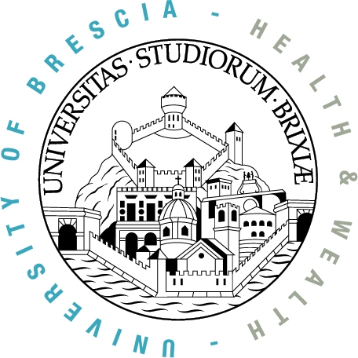

Università degli Studi di Brescia
Dipartimento di Giurisprudenza

INTERNATIONAL SUMMER SCHOOL

Comparing Italian and Chinese Legal Experiences: Between Tradition and Innovation

Brescia 6 – 10 July 2015

Department of Law
Via S. Faustino, 41 – Brescia

The summer school aims at offering a deep education program on principles and characteristics of the ancient Roman legal system, as well as on the process of unification of the law. As regards the unification process, special attention shall be devoted to those processes taking place within the international integration frame of reference, and in particular within the relationship between the European and Italian legal experience, on one side; and the Chinese legal experience, on the other side.
The lessons addresses bright students from Italy and China, selected according to strict criteria in order to guarantee the highest level of attendance. Students applying to the Summer School are required to possess a five – year or at least four-year course title in Law, or a second level Master in Law or any equivalent title.
The subjects dealt with in the Summer School course are listed hereunder:
- Introduction to Ancient Roman law system and contemporary law systems within the romanistic legal tradition
- Main features of the legal systems belonging to the Roman family, with a special reference to European legal systems and to China
- Integration models in Europe and China

programme

Monday 6 July 2015
Roman LAW
14,30
Prof. Maurizio Memo
Vice Dean of the University of Brescia
Prof. Saverio Regasto
Director of the Department of Law - University of Brescia

15,00-16,30
Prof. Aldo Petrucci
University of Pisa
17,00-18,30
Prof. Iole Fargnoli
University of Milan/University of Bern

Tuesday 7 July 2015
Private Law
9,30- 11.00
Prof. Zhai Yuanjian China University of Political Science and Law (CUPL)
11,30-13,00
Prof. Valerio Pescatore
University of Brescia

15,00-16,30
Prof. Laura Formichella
University of Rome ‘Tor Vergata’
17,00-18,30
Prof. Cristina Amato
University of Brescia

Wednesday 8 July 2015
International Law and European Union Law
9,30-13,00
Visit of the Court of Brescia

15,00-16,30 –
Prof. Patrizia De Cesari
University of Brescia

17,00-18,30
Prof. Marco Frigessi di Rattalma
University of Brescia

Thursday 9 July 2015
Comparative Private Law
9,30-11,00
Prof. Tatiana Alexeeva
National Research University ‘Higher School of Economics’ – St. Petersburg
11,30-13,00
Prof. Marina Timoteo/dott. Angela Carpi
University of Bologna

15,00-17,00
Workshop – The Role of Roman Law in the Unification of Law between Italy and China
Antonio Saccoccio/Xin Chongyang (chairs)
Prof. Wang Yong
China University of Political Science and Law (CUPL)
Prof. Giorgio Pedrazzi
University of Brescia
17,15-18,45
Prof. Marco Belfanti (University of Brescia)
Dott. Stefano Porcelli (University of Rome ‘Tor Vergata’)
Dott. Aleksander Grebieniow (University of Bern)
Dott. Francesco Ambrosini (Notary in Brescia)
Avv. Andrea Colantoni (Lawyer in Rome)

Friday 10 July 2015
Civil Procedure
9,30-11,00
Prof. Giuseppe Finocchiaro
University of Brescia
11,30-13,00
Prof. Luca Passanante
University of Brescia

